USER ENGAGEMENT ANALYSIS FOR RESTAURANT SUCCESS
About YELP
Yelp is a web and mobile platform that functions as a crowd-sourced local business review site. Users can submit reviews, photos, and tips about businesses, while also browsing information and ratings left by others.
Problem Statement
In a competitive marketlike the restaurant industry, understanding the factors that influence business success is crucial for stakeholders. Utilizing the Yelp dataset, this project aims to investigate the relationship between user engagement (reviews, tips, and check-ins) and business success metrics (review counts, ratings) for restaurants.
Research Objectives
- Quantify the correlation between user engagement (reviews, tips, check-ins) and review count/average star rating.
- Analyze the impact of sentiment on review count and average star rating.
- Time Trends in User Engagement.
Hypothesis
- Higher level of user engagement (more reviews, tips, and check-ins) correlate with higher review counts and ratings for restaurants.
- Positive sentiment expressed in reviews and tips contributes to higher overall ratings and review counts for restaurants.
- Consistent engagement over time is positively associated with sustained business success for restaurants.
Data Overview
- This dataset is a subset of Yelp and has information about businesses across 8 metropolitan areas in the USA and Canada.
- The original data is shared by the Yelp as JSON files.
- The five JSON files are business, review, user, tip and check-in.
- The JSON files are stored in the database for easy retrieval of data.
Analysis and Findings
- Out of 150k businesses, 35k are restaurants business and are open.
- Table showing distribution of business success metrices (review count and average ratings):
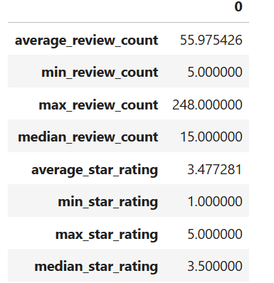
Highest Rating Highest Review Count
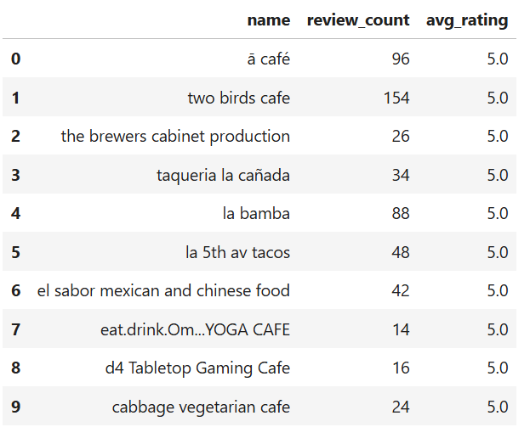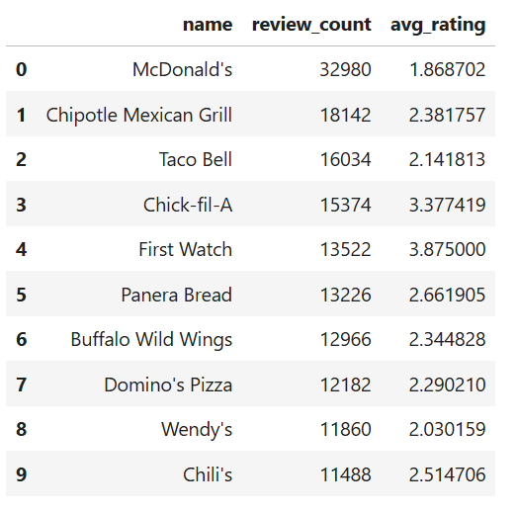
- Higher ratings do not guarantee a higher review count, or vice versa.
- Success of Restaurants is not solely determined by ratings or review counts.
- Review count reflects user engagement but not necessarily overall customer satisfaction or business performance.
Do restaurants with higher engagement tend to have higher ratings?
- Data shows a general increase in average review, check-in, and tip counts as ratings improve from 1 to 4 stars.
- Restaurants rated 4 stars exhibit the highest engagement and show a downward trend for ratings above 4.
- The drop in engagement at 5.0 stars might suggest either a saturation point where fewer customers feel compelled to add their reviews, or a selectivity where only a small, satisfied audience frequents these establishments.
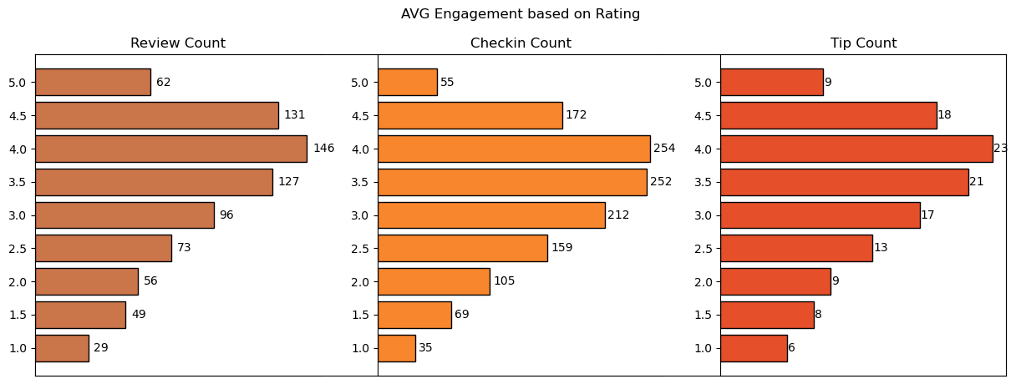
Is there a correlation between the number of reviews, tips, and check-ins for business?
- These correlations suggest that user engagement across different platforms (reviews, tips, and check-ins) is interlinked; higher activity in one area tends to be associated with higher activity in others.
- Businesses should focus on strategies that boost all types of user engagement, as increases in one type of engagement are likely to drive increases in others, enhancing overall visibility and interaction with customers.
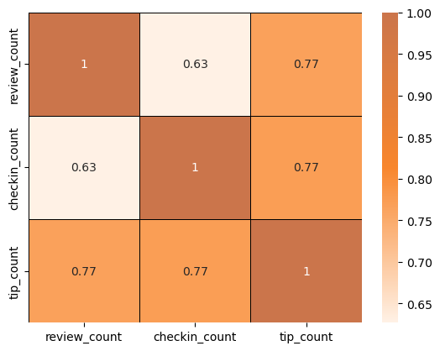
Is there a difference in the user engagement between high-rated and low-rated businesses?
- Data indicates a clear correlation between higher ratings and increased user engagement across reviews, tips, and check-ins.
- This pattern underscores the importance of maintaining high service and quality standards, as these appear to drive more reviews, check-ins, and tips, which are critical metrics of customer engagement and satisfaction.
How do the success metrics of restaurants vary across different states and cities?
- Philadelphia emerges as the top city with the highest success score, indicating a combination of high ratings and active user engagement.
- Following Philadelphia, Tampa, Indianapolis, and Tucson rank among the top cities with significant success scores, suggesting thriving restaurant scenes in these areas.
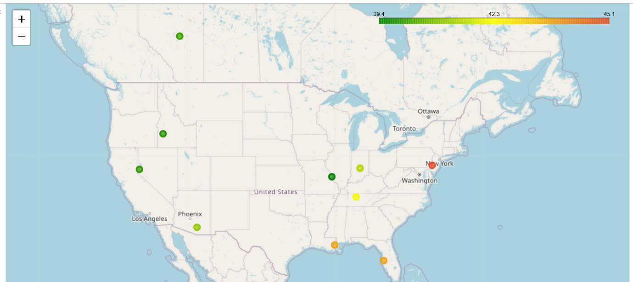
Are there any patterns in user engagement over time for successful businesses compared to less successful ones?
- Successful businesses, particularly those with higher ratings (above 3.5), exhibit consistent and possibly increasing user engagement over time.
- High-rated restaurants maintain a steady or growing level of user engagement over time, reflecting ongoing customer interest and satisfaction.
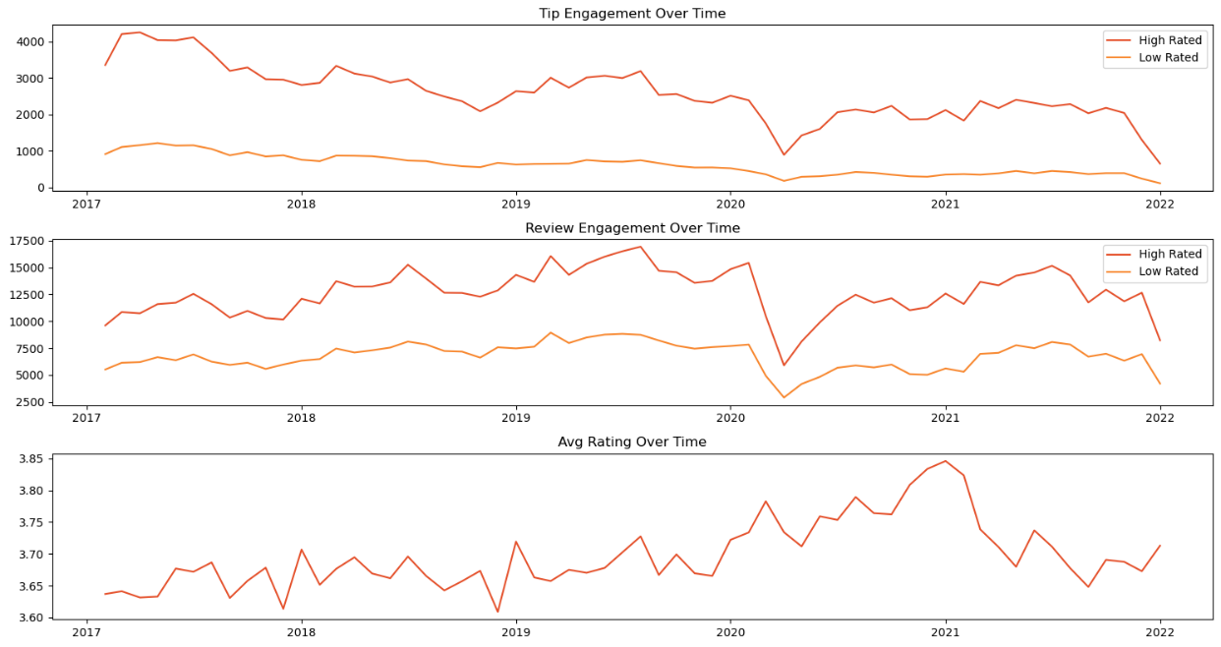
Trend and Seasonality Analysis
Tip Count Review Count
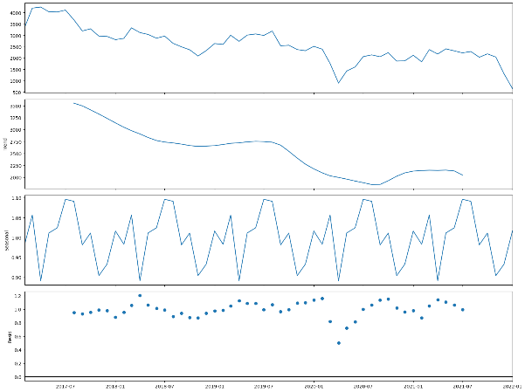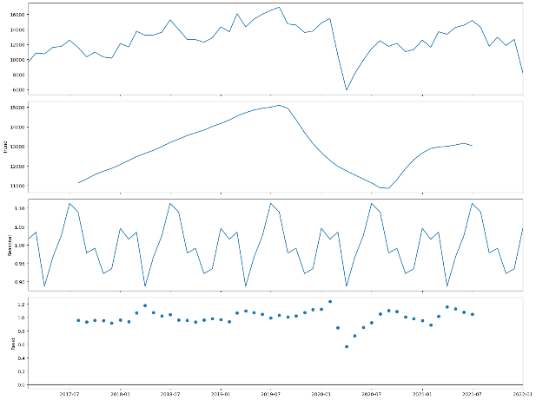
How does the sentiment of reviews and tips (useful, funny, cool) correlate with success metrices of restaurants?
- “Useful,” “funny,” and “cool” are attributes associated with user reviews. They represent the feedback provided by users about the usefulness, humor, or coolness of a particular review.
- Higher counts of useful, funny, and cool reviews suggest greater user engagement and satisfaction, which are key factors contributing to a restaurant’s success.
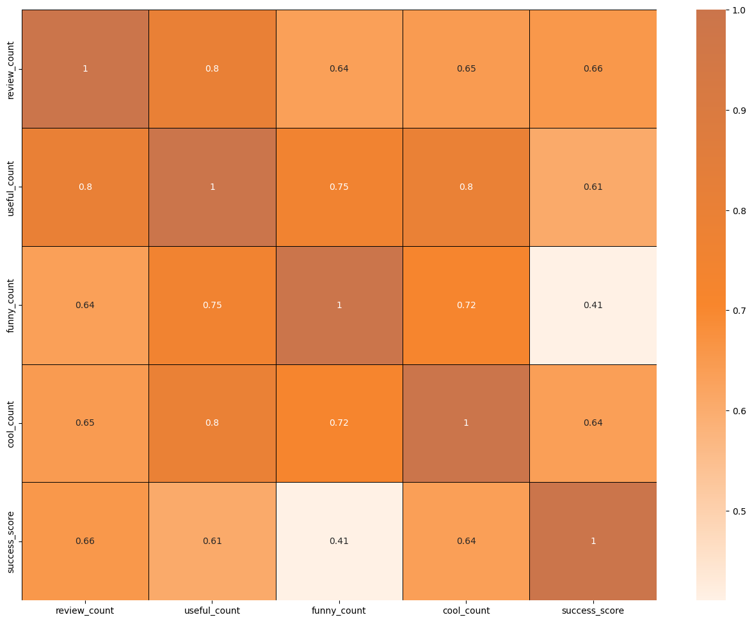
Is there any difference in engagement of elite users and non-elite users?
- Elite users are individuals who have been recognized and awarded the “Elite” status by Yelp for their active and high-quality contributions.
- Elite users, despite being significantly fewer in number, contribute a substantial proportion of the total review count compared to non-elite users.
- Establishing a positive relationship with elite users can lead to repeat visits and loyalty, as they are more likely to continue supporting businesses they have had good experiences with.
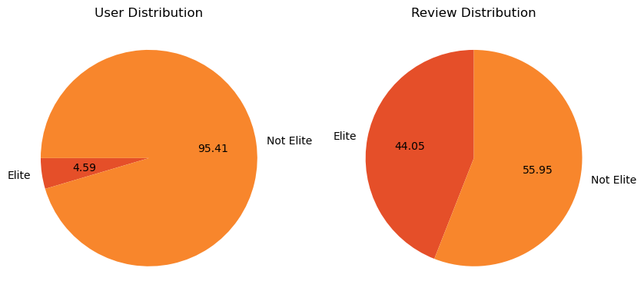
Busiest Hours
- The busiest hours for restaurants, based on user engagement, span from 4 PM to 1 AM.
- Knowing the peak hours allows businesses to optimize their staffing levels and resource allocation during these times to ensure efficient operations and quality service delivery.
- The concentration of user engagement during the evening and night hours suggests a higher demand for dining out during these times, potentially driven by factors such as work schedules, social gatherings, and leisure activities.
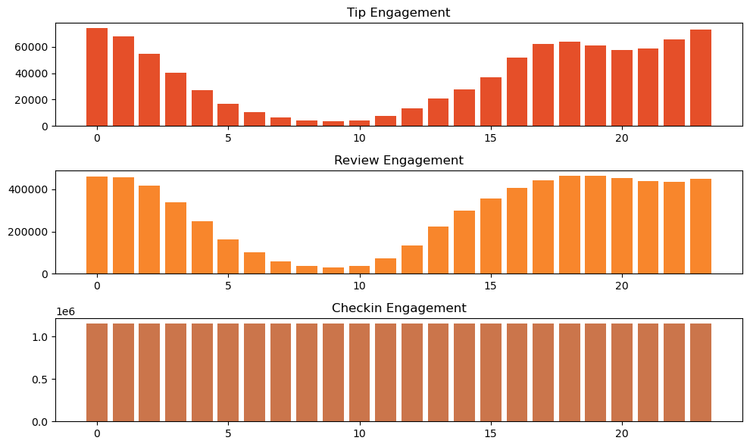
Recommendations
- Utilizing insights from the analysis of various metrics such as user engagement, sentiment of reviews, peak hours, and the impact of elite users, businesses can make informed decisions to drive success.
- Collaborating with elite users and leveraging their influence can amplify promotional efforts, increase brand awareness, and drive customer acquisition.
- Businesses can adjust their operating hours or introduce special promotions to capitalize on the increased demand during peak hours.
- Less successful businesses may need to focus on strategies to enhance user engagement over time, such as improving service quality and responding to customer feedback.
- Cities with high success scores present opportunities for restaurant chains to expand or invest further.

